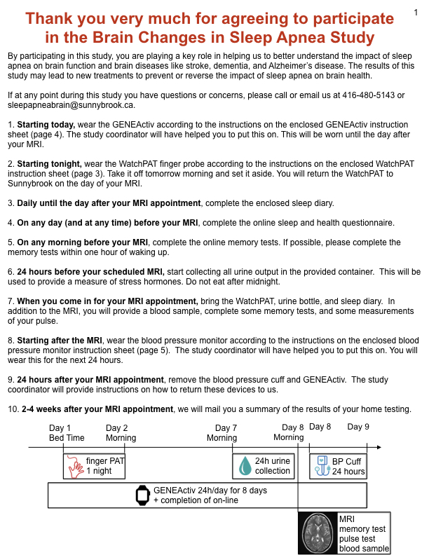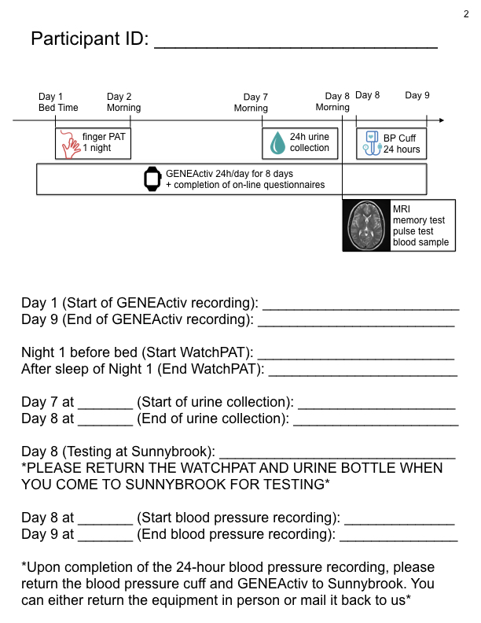
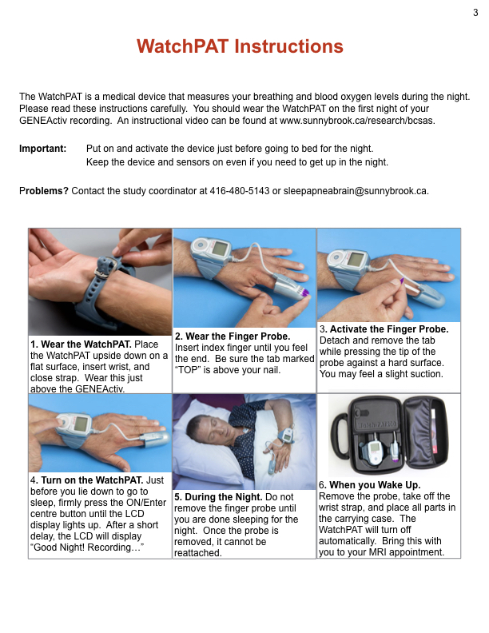
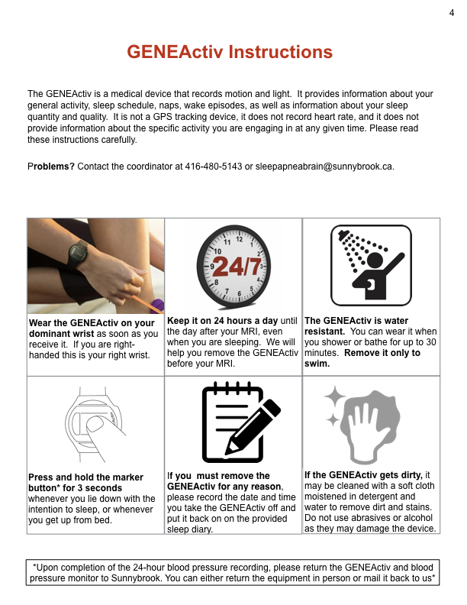
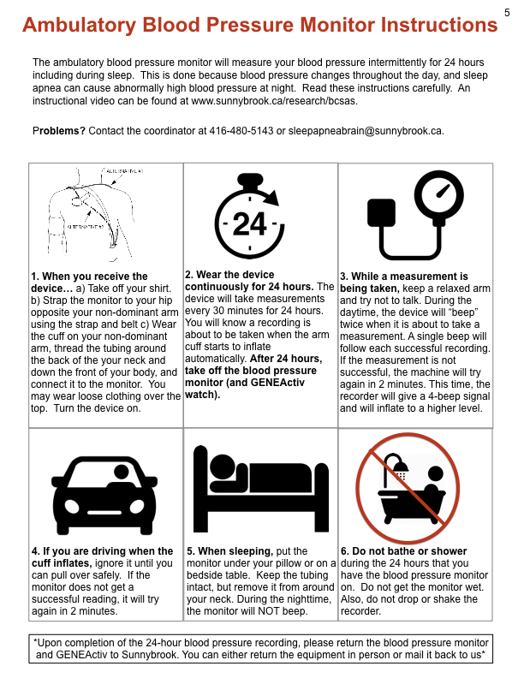Instructions for 24-hour Urine Collection
6

- On the day before your MRI, you MUST start your 24-hour urine collection in the morning. Empty your bladder when you get up in the morning and DISCARD THIS URINE (ie. do NOT put it in the urine collection bottle). Record the date and time that you discarded your first urine of the day. Record this on the sheet below to indicate the beginning of your 24-hour urine collection.

- After you discard your first urine of the day, collect in the bottle ALL URINE you pass today and tonight.

- On the morning of your MRI, empty your bladder at the SAME HOUR that you discarded your urine on the previous day, and add all this urine to the full bottle. Record the date and time of this last collection on the sheet below to indicate the end of your 24-hour urine collection.

- Bring the bottle and this sheet to Sunnybrook when you come in for your MRI.

The urine collection bottle must be kept refrigerated during the 24 hours and until the time it is returned to Sunnybrook.

DO NOT void directly into 24-hour urine bottle as the container may have a preservative added which may be corrosive. Instead, void into a clean container and then carefully pour the urine into the collection bottle. In case the preservative comes in contact with skin, flush with plenty of water.

Do not drink excessive quantities of fluids or take non-prescribed drugs during the 24-hour collection period.

Please restrict caffeine, nicotine and alcohol for the 24 hours prior to and during your 24-hour urine collection. Discontinue Methyldopa (Aldomet) for at least 5 days prior to collection.

Label the 24-hour urine container with your full name and date of birth.

Below, indicate the date and time the collection was started and date and time it was finished.

Date Started: (yyyy/mm/dd) | Time Started: am  pm
Date Finished: (yyyy/mm/dd) | Time Finished: am  pm

If you have any questions/concerns, please call/email the research coordinator at 416-480-5143 or sleepapneabrain@sunnybrook.ca.

